Faculty of Computing



**[CCN]**

**Lab No 9 Tasks**

**Name: Maryam Mehreen**

**Sap id: 35889**

**Task 1:**

**Perform all the tasks in the manual and take screenshot. (10 marks)**

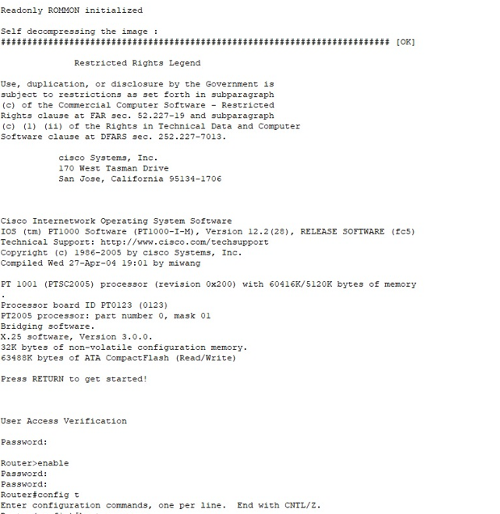

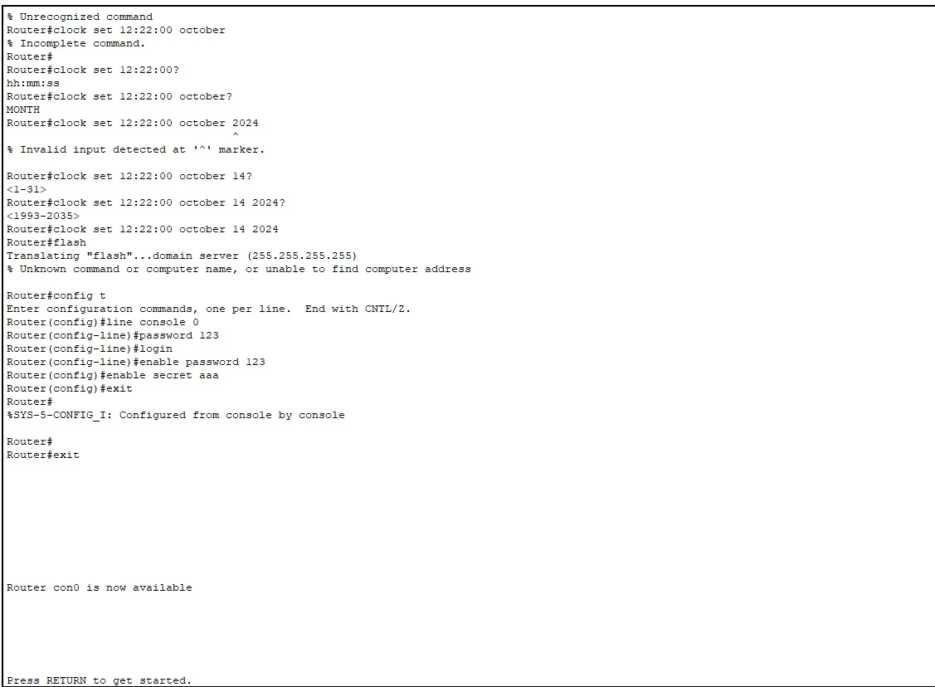

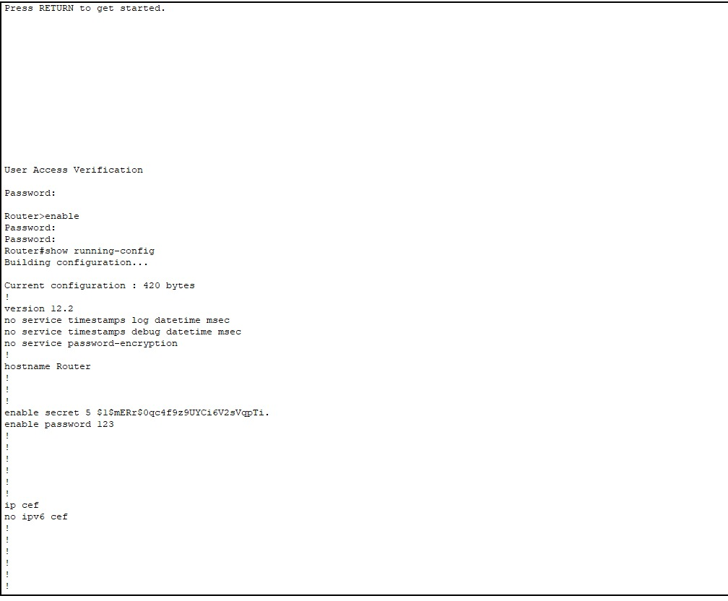

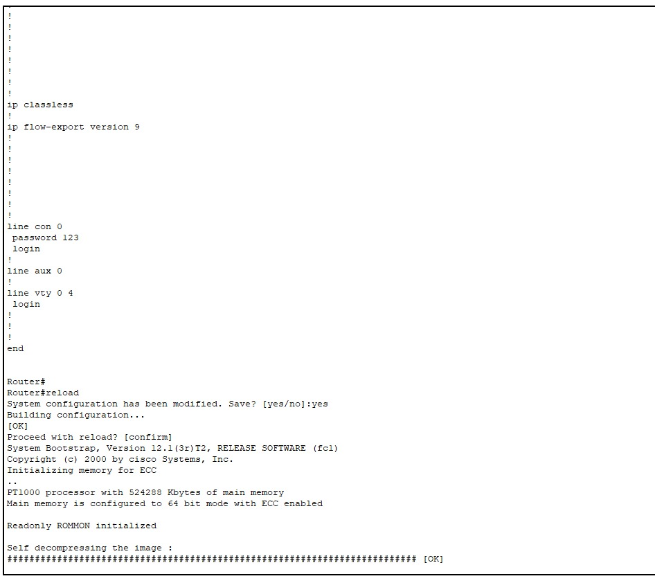

**Task 2:**

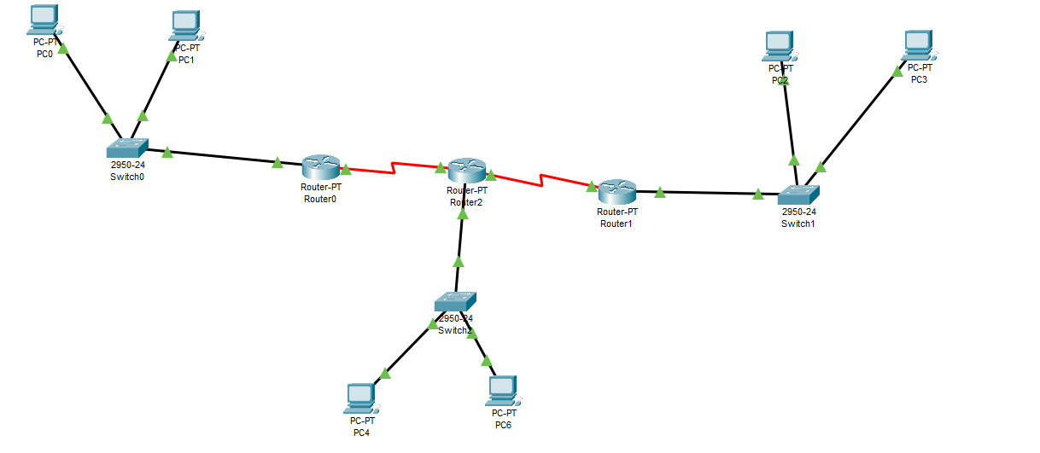

**Create the above topology using commands. And ping each pc using command prompt an**

**d show the results. (10 marks)**

**Solution:**

